**How to run the jar and where to find the log?**

1. Run mvn clean install.
2. Run the uber jar

1.1 Navigate to ksubaka/target

1.2 **Example** :-

Movie :- java -jar -Dapi=themoviedbapi -Dmovie="TED" ksubaka-1.0-SNAPSHOT.jar

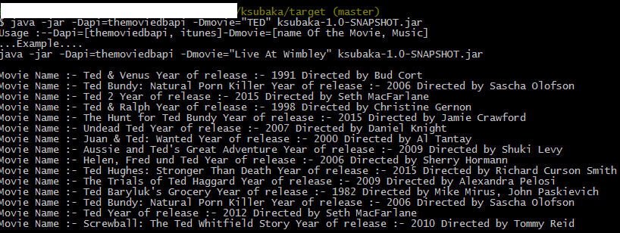

Music :- java -jar -Dapi=itunes -Dmovie=”When We Were Young” ksubaka-1.0-SNAPSHOT.jar

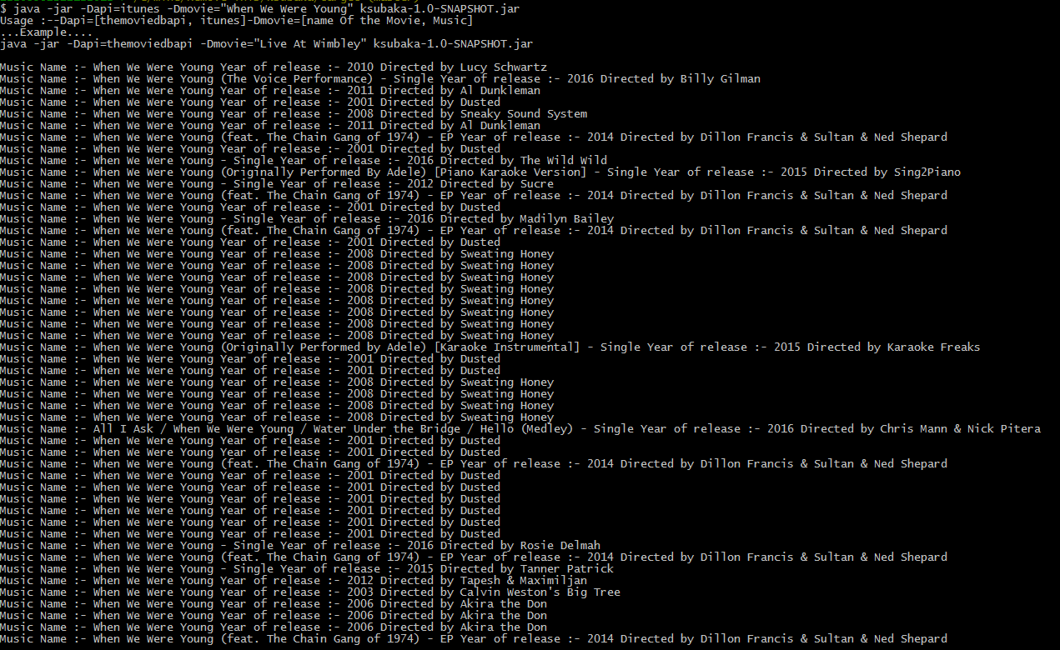

1. To see the log

2.1 Navigate to ksubaka/target/log

2.2 Open log4j-application.log